Success Stories
1. An entrepreneur with pig breeding farm
With an aim to utilize kitchen waste as suggested by my mother Late Dangi Murmu, I bought 2 piglets of improved breeds from Green Dream Farm (Pig breeding farm of Mr. Jerome Soreng), Gorgora, Baliguma in the year 2008. I often used to visit the pig farm owned by Mr. Soreng for suggestion and advice. His dedication, hard work and his healthy pigs in the farm generated curiosity in me to start pig farming.
In the mean time I got the information of a programme organized by Krishi Vigyan Kendra, East Singhbhum at Gorgora on “Capacity building of Pig Farmers” and I was fortunate enough to attend it. I could conceive scientific methods of pig farming. Good breeds, housing and feed management, healthcare and marketing strategies in pig rearing were discussed in the programme by the expert scientists. In the mean time I could manage to construct two rooms for the pig rearing. I bought five females and male piglets of T&D breed to start my dream project.
Consistent support and expert knowhow of Dr. Rabindra Mohan Mishra, Subject Matter Specialist (Animal Husbandry), Krishi Vigyan Kendra, Darisai, East Singhbhum under Birsa Agricultural University, made me feel confident in going with the project. I could attend a number of programme organized by KVK both on and off the farms. Now I was quite ambitious with the project. My first batch of five pigs started furrowing piglets one after other after about a year. I could fetch good returns from the first lot by selling about 32 piglets for Rs 35200/- (Rs. Thirty Five thousand and two hundred only).
The second furrowing, just after about seven months shocked me and shook my confidence as the newly born piglets started dying at about two to five days. Dr Mishra of KVK diagnosed the problem and said that the occurrence was due to faulty feeding and management during pregnancy period. The piglets died due to agalactia i.e. no milk secretion in the udder due to over feeding and overweight sows. I learnt a lesson to manage my breeding stock by providing balanced feeding and management. Then onwards I never looked back and the enterprise has proven a boon for me and my family.
I bought a carry van (Tata Ace) to collect kitchen waste from Jamshedpur on loan received from Gramin Bank, Dimna, Jamshedpur. In the mean time I received some good T& D Pigs from Krishi Vigyan Kendra for demonstration too. Gradually I expanded my farm and increased the number of breeding stock in my farm. I am happy to say that I got some pigs of Ghunghroo breed from KVK for experimenting its performance and is very much liked by the rural farmers. About three hundred plus families have been benefited with improved pig rearing through me. About fifty farmers come to visit my farm every month. KVK, Darisai has promoted many farm families to adopt pig farming through exposure to my farm.
By the end of 2013 I am proud to say that I have expanded my farm for keeping about 150 (one hundred and fifty) pigs in Bhagaband, near Pipla, Jamshedpur. I have sold pigs (both piglets and fatteners) for Rs five lakhs in 2013 by spending about Rs one lakh eighty thousand only. I have projected to sell pigs for Rs eight lakhs in this year by spending about Rs three lakhs only.
I am happy and confident on this enterprise and it is proving to flourish in the days to come.

2. Pig Farming- An enterprises with success
Mangal Murmu, a young dynamic villager of Bhagaband in Beko Panchyat was motivated to adopt commercial pig farming during a training programme organised by Krishi Vigyan Kendra in the year 2008. He was exposed to pig farms at Gorgora in Jamshedpur and RVC Ranchi. He started a pig farm with a very low investment of Rs 7500/ (seven thousand five hundred only). He purchased one male and four female piglets of T & D pig breeds and maintained in a two room concrete housing. The feed management was as per the recommendation of KVK expert (50% Kitchen waste + 50% grain). His objective of initiating the farm was to learn the basics of pig farming and to gain experience. He skilled himself in vaccination techniques and basics of pig health care through attending training programmes frequently organised at KVK. Krishi Vigyan Kendra East Singhbhum further strengthened his farm by demonstrating elite stock of T&D and Ghoongroo breed pigs.
After about a year he received 25 piglets from the four first time farrowers(sows). As per his plan he sold the piglets at two months old age each for Rs. 1200 and received an income of Rs 30,000. He constructed four roomed shed with thatched roof. By the end of year 2009, he procured 6 more sows as breeding stock and a boar from RVC, BAU, Ranchi. From 2010 onwards Shri Murmu never looked back and is now one of the successful pig growers of East Singhbhum.
At a glance on time-line of Sri Mangal Murmu
Year | No of pigs (in the year) | Total income/ year | Net income/ year | Remarks
2009 | 6 adults +30 piglets | 30000 | 12000 | Dissemination of T&D -12 households
2010 | 12(sow)+2(male) breeding stock + 64 piglets | 75,000 from piglets+ 25,000 from fatteners | 45,000 | 33 Households adopted T&D
2011 | 15+ 3,  145 piglets | 1,50,000 from piglets + 70,000 from fatteners | 1,00,000 | 50 households
2012 | 20 +4+ 185 piglets | 3,00,000 | 1,60,000 | -A new farm in 4000 sq ft area is developed with 18 sheds.  -A Tata Ace is purchased(financed)  -Ghoongroo breed introduced
2013 | 24+4+ 200 piglets | 4,00,000 | 2,10,000 | -farmers’ meet organised  -12 exposure visits organised at farms  -Shri Murmu was called as a resource person to motivate new farmers  -pig farming is disseminated widely

In the end of 2013, the farm has about 35 adult pigs(28+7), 43 castrated males, 64 piglets(15 to 25 kg. weight). Seeing the potency, Gramin Bank has released 2,50,000 as a loan to further strengthen the farm. It is an encouraging success story for those who seek employment through livestock farming.
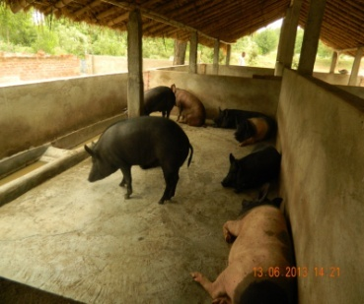
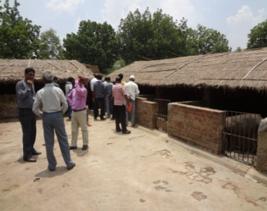
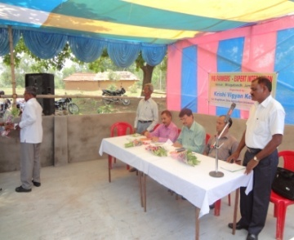
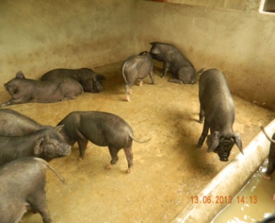

3. Borax: Boon for cauliflower growers in East Singhbhum

In East Singhbhum district cauliflower is grown as mid & late season crop & cultivated in almost 11 blocks of our district. The soil of the district is 77% acidic & its pH varies from 4.1 to 7.3. Cauliflower crop act as indicator plant for boron deficiency & it is immobile in acidic soil therefore, deficiency symptoms first appeared on its vegetative parts like browning of curd & hollowness in stem part. Continuous & intensive cultivation of vegetable in same field also responsible for boron deficiency in soil & sometimes rotting & browing of curd head goes to an extent of 70 to 80%. Since, establishment of KVK, East Singhbhum it was observed that farmers used to sprayed pesticide, other chemicals or growth hormones to overcome of this problem that was due to their unawareness.
Keeping this in view a OFT was conducted in 10 farmer’s field during 2006-07, after getting satisfactory result in application of borax in spray @ 15 kg/ ha (Yield 203.20 q/ha and 10% rotting) as compared to soil application of borax @ 10 kg/ha (Yield 194.20 q/ha and 15% rotting) control (Yield 153.20 q/ha and 40% rotting) it was verified through Front line demonstration in Patamda, Jamshedpur, Ghatsila, Dhalbhumgarh and Potka block during 2008 & 2012 to judge the efficiency of borax in minimizing the menace.
The result indicated increased production & productivity that might be possible only due to decreased browning & rotting of heads of cauliflower. Field day (5 nos) was also organized for it broader dissemination. The farmers were convinced of application of borax in spray @ 15 kg/ha twice, first after 20-25 DAT & second 40-45 DAT sowing for its effective result. Through FLD 115 farmers of Potka block, village Bhurkadih implemented borax trial in their cauliflower field during 2012 & were benefited much. The browning & rotting of curd was also observed negligible. The curd colour, firmness was also found better. On an average 375 q/ha yield was observed in borax sprayed field as compared to 195 q/ha in control. The net return was found to be around Rs. 1,12,500.00 per ha, where as benefit cost ratio was 2.50.
Now other farmers of the village Bhurkadih & nearby villagers adopted this practice. As borax is available in local market therefore farmer are not facing any difficulty in its purchases.
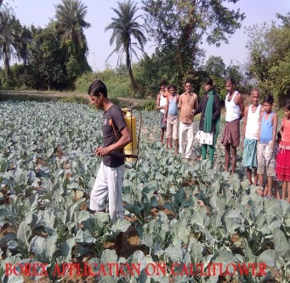
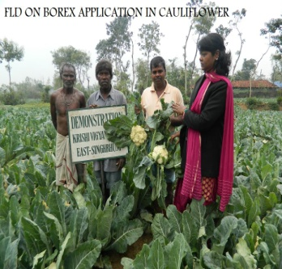
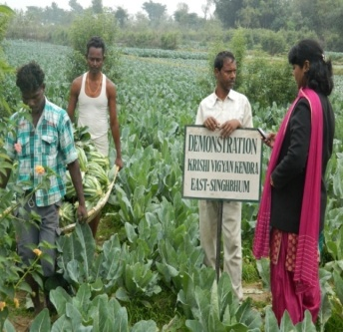
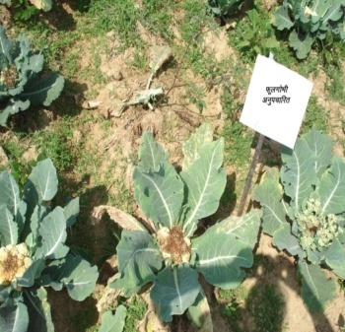

4. With the commencement of Krishi Vigyan Kendra, East Singhbhum in 2004-05 the experts of KVK engaged themselves to identify the potential areas where intervention could be made for a significant outcome. It was possible through exercising the different survey tools that in the Santhali dominant district, one of the sectors with a tremendous potency was pig rearing.
With the aim of enhancing the productivity in pig farming T & D breed was chosen for the front line demonstration. First demonstration on the T & D breed was conducted in the villages Sidhadanga and Susnigaria of Ghatsila block. Farmers Sri Durga Majhi and Sri Diku Soren was given T & D piglets a male and a female and a male & two female, respectively on the eve of first “Kisan mela” organised on 31st January 2006 at KVK, East Singhbhum. Both the farmers were trained for scientific ‘rearing of pig’. Regular visit by KVK experts to the farmer’s field and guidance strengthened their skills. Both the farmers managed their pigs with farm residues and kitchen wastes. By the end of the year 21 piglets were farrowed with almost two farrowing per year received by the farmers there after. Till the end of 2008, Sri Durga Majhi of Sidhadanga had 28 piglets and Sri Diku Soren of Susnigaria got 60 piglets. They had respectively earned Rs. 30000.00 and Rs. 60000.00 each by selling the piglets. The grand and significant success in the view of KVK was a wide dissemination of the most suited, black colored, quick body weight bearing, highly prolific, well adoptive, disease resistant T & D breed among many villages of the district. A few could be named as Sukrigariya, Narga, Bhilaipahari, Kanyaluka, Roam & Cholagora, Jagannathpur, Naldoha etc are the villages under different blocks of the district.
With the perception that the breed was performing so well in the region KVK, East Singhbhum carried its voyage for its further dissemination through organising FLDs on pigs. In the year 2007, Prof J. Soreng, a retired person who adopted farming as a hobby was selected as a resource rich farmer for T & D’s demonstration in KVK’s adopted village Gorgora in Jamshedpur block. He participated in training programmes & workshops organised by KVK very frequently. Two males and four females of pigs were given in demonstration. Mr. Soreng’s dedicated, hard work and interest had emmersed his farm as a model pig farm for the new comers in pig rearing occupation. Now, he is maintaining about fifty pigs of T & D and could be able to provide piglets to the farmers of the East Singhbhum and Saraikela Kharsawan districts. His annual income through the sell of piglets was about Rs. 1.0 lakhs and finished pigs (fatteners) were Rs. 85000.00 (Rs. Eighty five thousand only).
By organising frequent training, workshops, exposure visits and field days at the successful farmers’ farm we were able to equip our farmers with the recent techniques of pig farming. Farmers of Bhagabandh, Baghuriya, Chakuliya, Gorgora, Jagannathpur, Ulda, Naldoha, Sunderdih are the one among many who have started pig farming as an enterprises. Their new venture has started rewarding good returns compared over their traditional pig rearing methods. Coming to the peroration, KVK, East Singhbhum with a dream sails in a boat of hope to continue its journey with the inspiring words that “Knowing is not enough; we must apply willing is not enough; we must do it.”
DETAILS OF FLD GIVEN IN THE LAST THREE YEARS
SL NO | NAME OF FARMERS | VILLAGE | BLOCK | YEAR OF DEMONS. | INCOME TILL 2008 (In Rs.) | PIGS DEMONSTRATED
1. | Durga Majhi | Sidhadanga | Ghatsila | 2006 | 30000.00 | 1M & 1F
2. | Diku Soren | Susnigaria | Ghatsila | 2006 | 60000.00 | 1 M & 2 F
3. | Matul Mardi | Lowkeshra | Musabani | 2007 | 4000.00 | 1 M & 2 F
4. | Subodh Mardi | Roam | Potka | 2007 | 5000.00 | 1M
5. | Jerom Soreng | Gorgora | Jamshedpur | 2007 | 70000.00 | 2M 4 F
6. | Dev kumar Soren | Baghuriya | Ghatsila | 2007 | 16000.00 | 2 F
7. | Sonaram Soren | Baghuriya | Ghatsila | 2007 | 10000.00 | 2 F
8. | Soken Soren | Sidhadanga | Ghatsila | 2008 | -- | 2 F
9. | Sankar Manjhi | Deoli | Ghatsila | 2008 | -- | 1 M & 1 F
10. | Biren Hansda | Banamghutu | Jamshedpur | 2008 | -- | 1 M & 1 F

Some of the farmers who started pig farming in different block of the districts (After taking trainings).
SL NO | NAME | VILLAGE | BLOCK | NO OF PIGS
1. | Mangal Murmu | Bhagabandh | Jamshedpur | 15
2. | N. Baskey | Sarjamda | Potka | 4
3. | D. Mardi | Sarjamda | Potka | 4
4. | B. Murmu | Baliguma | Jamshedpur | 2
5. | Sunil Hembrom | Birsanagar | Jamshedpur | 10
6. | Ratan |  | Patamda | 4
7. | Somai |  | Patamda | 4
8. | Sravan |  | Patamda | 4
9. | Ghuhiram Majhi |  | Dhalbhumgarh | 2
10. | Singrai Tudu | Kanyaluka | Dhalbhumgarh | 2
11. | Jasai Hansda | Bhadua | Musabani | 2
12. | Uma Sankar | Jugsalai | Jamshedpur | 30
13. | Sanatan Mardi | Raghunathpur | Chakulia | 10
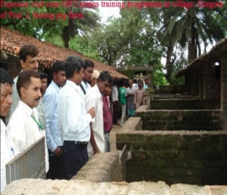
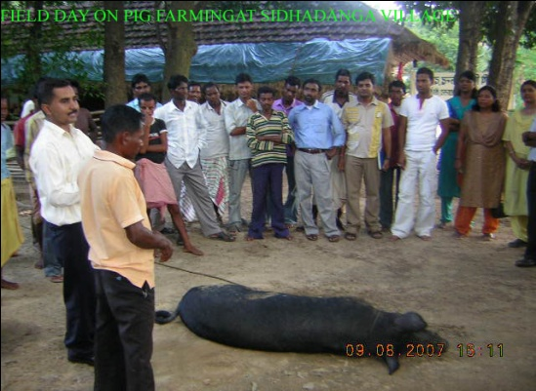

5. Crop diversification through banana cultivation

Name of the farmer | Shri Jadunath Soren
Village | Rawtara, Dhalbhumgarh
Block | Dhalbhumgarh
Address | Vill. &PO- Rawtara, Dhalbhumdarh,  East Singhbhum, Jharkhand
Contact details | 09234118340
Landholding (in hectare) | 1.7
Irrigated | -
Un-irrigated | -
Membership details | Kisan club but unregistered
Shri Jadunath Soren is a dedicated rural youth who has proven himself as a successful commercial farmer in his locality. His father shri Majia Soren and mother Smt. Kapra Soren is proud of their son who is earning name and fame through agriculture and allied sectors. Shri Jadunath posses intermediate degree in science. As on November 2014 he is forty years old. He is a bachelor. The soft spoken, sober and optimistic Soren has strong belief in success through commercial farming. He developed interest in farming in 2004-05. Many proven technologies have been disseminated to adjoining villages, panchyat and blocks by him. He firmly decided to go commercial by adopting advanced technologies available. Distribution of different components in his farm is crops like paddy, mustard, wheat, banana, plant nursery and livestock like poultry and goat in 1.7 ha farm. For acquiring information on the new subjects he approached Krishi Vigyan Kendra, East Singhbhum. There he participated in various training programmes like Integrated farming system, micro-irrigation technique, pig based farming system, seed production technique, Methods of System of Rice intensification (SIR), lac cultivation, commercial hor.
Shri Jadunath soren’s success in commercial farming came when he took banana cultivation in one acre ledge land in his village. The land chosen was upland (cultivable waste land). His keen interest in banana cultivation was ignited when he attended a vocational training programme in ‘commercial horticulture in KVK. He planted 750 saplings of tissue cultured bananas prepared at tissue culture laboratory, Krishi vigyan Kendra, East Singhbhum. He started plantation in early 2012 with two varieties- Grand-9 and Robusta. He treated the soil using lime, neem cake, compost (cow dung). He irrigated the plants using water from his own pond. He reduced moisture stress using dried leaves and compost mulching around each banana plants. Flowering and fruiting started in February 2013. He could sell about 200 Kandhis in June-July 2013 at the rate of Rs 200 each Kandhi. Thereafter Shri Soren sold banana for Rs two lakhs fifty thousand till December 2014 from his nursery
Shri Jadunath Soren, a young dynamic rural youth did not satisfy himself with improved paddy cultivation using SRI technique, hy-breed paddy cultivation, wheat and mustard cultivation and banana cultivation but introduced horticulture nursery in his own one acre land (0.4 ha). As per the huge demand after the success shown by him many farmers from adjoining villages and panchyats raised the demand for banana saplings and other vegetable and fruit planting materials. He already started selling the plants from his nursery named Chaiey Ghar Nursery.
Shri Soren has not only been able to gain confidence in himself but the farming community as a whole.
For holistic lively-wood development Shri Soren has maintained livestock in his backyards. According to him.
Award, reward and appreciation received | - Birsa SRI Srestha award for SRI promotion  - Promotion of pulse crop (Arhar)  - Best farmer award for SWI demonstration  - Progressive farmer of the district award
Impact factors | Before adoption | After adoption
Crop/ agriculture practice | Mono cropping | Crop diversification and intensification
Yield of crop/ product | Paddy = 20 q/ha  Arhar= 8 q/ ha | Paddy= 28q/ha  Arhar= 11q/ ha  Banana =400q/ha  Banana saplings= 3000
Sale value | Rs.35,000 | Rs. 2,56000
Input cost | Rs.10,000 | Rs. 50,000
Labour cost | Rs. 5000 | Rs. 20,000
Any other cost | Rs. 2000 | Rs. 4000
Net saving/ net profit | Rs 18,000 | Rs. 1,82000
6. Participatory mode bring prosperity in NICRA village
Lowkeshra & Barunia village of East Singhbhum district was brought under NICRA project owing to its climatic vulnerability of low rainfall (820 mm) with a span of June to September (four month). However, like other parts of the district, NICRA adopted village also experienced uneven & meager distribution of rainfall. For the last few years there is high variability in the rainfall pattern during monsoon which severely affected crop cultivation, animal rearing & domestic waster consumption. These villages experienced drought for consecutive year & became drought prone at the long run. Therefore creation of irrigation facility in the village was the only way to bring prosperity in the village through round the year crop & vegetable cultivation.
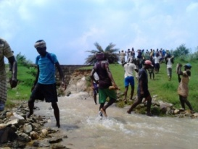
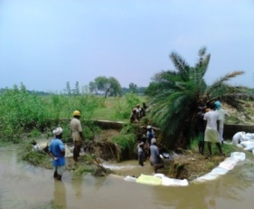
Through PRA survey it reveals that on that village one old check dam (500× 75× 3 ft) was existed but due to damage coverage of 35 ha area were affected. After meeting with villagers it was decided that damage portion will be renovate with sand bags in participatory mode. Material cost will be met out with NICRA project and free labour support will be provided by the villagers. This intervention was taken in participatory mode and with the investment of 15000.00 and 40 % work contribution by the villagers towards the cost of labour damage portion was repaired. With the construction of this, during 2013 kharif life saving irrigation was provided to nursery and during monsoon break at the time of transplanting, they successfully covered 15 ha area of land and with these 30 farm families were befitted. But during the same year in the month of October 2013 constructed portion (through Bora Bandi) was again damage due to Fylin it was serious matter of concern in front of all the villagers thus they call a meeting and it was decided with the fund of NICRA project inputs will be purchased and villagers will provide labour support. One week continuously all the villagers were engaged in making damaged portion of the check dam to pakka. With the investment of Rs. 60000.00 this check dam renovated during 2013-14
This year when district is facing low rainfall and monsoon break problem, villagers of NICRA are busy in transplanting paddy at present 70-75% land area has been covered. During rabi season also they will cover at least 35 ha area with wheat, mustard, chickpea, kulthi and vegetables. Now all are happy with their effort and of course with NICRA project they will be self sufficient in taking second crop. No doubt the cropping intensity of the project area will be increase with Kharif as well as rabi crop cultivation. It not only helped are extension but also aware and motivate farmers to solve village related issue through participatory mode. The approach of NICRA village is gradually disseminating to other part of the district having similar situation through huge paper and media coverage.
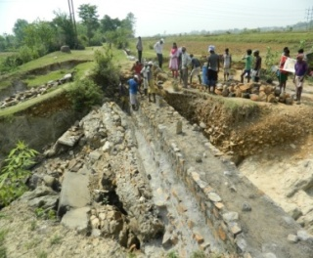
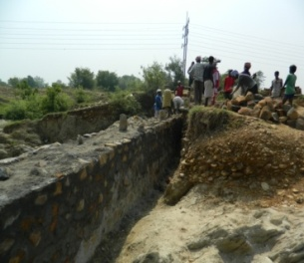
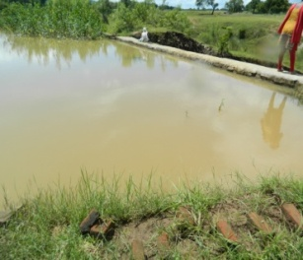
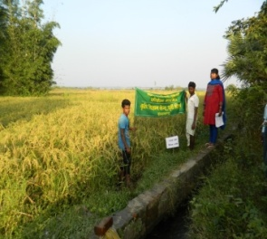

7. CROP + PIG CUM DUCK CUM FISH SYSTEM TURNS MATU’S FORTUNE

Sri Matu Mardi son of Sri Yadunath Mardi is Inter Pass 38 years old rural youth of village Lowkeshra, Musabani has transformed himself as a progressive farmers after the inception of NICRA project in his village. He used to cultivate rice as mono-crop with traditional method & domesticate livestock like pig, poultry & sheep. He has a pond of 100 feet × 100 feet × 5 feet depth but was unproductive for many years due to lack of knowledge & awareness about integrated farming system. He neither stocked composite species of fishes nor integrated improved duck, pig breed & crops cultivation. On an average he get net profit of Rs. 29400.00 with the investment of Rs. 80000.00.
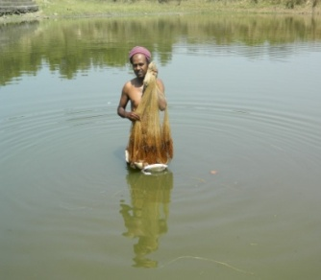
After getting guidance by the KVK scientists he constructed small hut during summer 2012, on the bank of pond. He clean the pond by removing all unwanted vegetation & cleaned the pond. He make outlet of pig house in to the pond & also add lime 4q/ha & cow dung 10q/ha in that pond on advise of the KVK scientists. In the month of July 2012 he added different species of fishes namely Rohu, Katla, Mrigal, Common carp, Grass Carp etc. as suggested by Scientists. Along with these he was supplied with 15 improved Khaki Campbell ducklings with 2(m) + 4 (F) pig (T × D) breed & in nearby adjoining areas he cultivated crops (eg. Mustard, Wheat, Gram) & vegetable (eg. Bitter gourd, Onion & Okra) & started integrating farming system in his land. Pig & duck excreta were the main source which benefited fishes, pond water was used to irrigate Rabi season crops whenever needed & vegetable wastes used as feed of duck & pig.
The overall productivity was found to increase tremendously & with investment of total amount of Rs. 141900.00 annually, he get net profit of Rs. 171500.00 in the first year (2013) that was ever noticed & gained by him earlier. The cost of cultivation will reduced in the coming year as he has not to invest money in pig, duck & infrastructure.
Now observing the benefits harnessed by Matu about 45% farmers in the localities having ponds have trying to adopt this model of farming system.
Sl no | Crop/ Enterprises | Pre NICRA |  |  |  | Post NICRA
 |  | Gross Return (Rs/ ha) | Cost of Cultivation (Rs/ha) | Net Return (Rs/ ha) | B:C | Gross Return (Rs/ha) | Cost of Cultivation (Rs/ha) | Net Return (Rs/ha) | B:C
1. | Rice | 32,000 | 15000 | 17000 | 2.13 | 48000 | 18000 | 30000 | 2.67
2. | Wheat | - | - | - | - | 35000 | 20000 | 15000 | 1.75
2. | Pig | 7,000 | 4000 | 3000 | 1.75 | 115000 | 40000 | 75000 | 2.88
3. | Poultry | 2,000 | 8,00 | 1400 | 2.5 | 4000 | 1200 | 3000 | 3.33
4. | Duckery | -- |  |  |  | 5000 | 1700 | 3500 | 2.94
5. | Fishery | 7,000 | 3,000 | 4000 | 2.33 | 20000 | 5000 | 15000 | 4.00
6. | Others (Veg+Spices) | 62,000 | 56,000 | 4000 | 1.11 | 90000 | 60000 | 30000 | 1.5
 | Total | 110000.00 | 78800.00 | 29400.00 |  | 317000 | 145900 | 171500
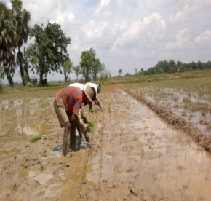
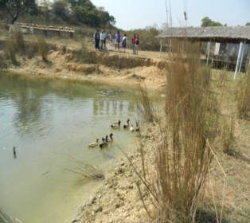
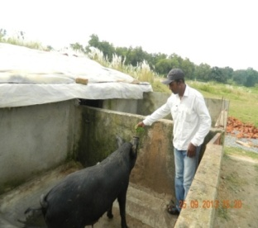

8. It is a story of Sri Durga Majhi, 27 years old youth of village Sidhadanga block Ghatsila, East Singhbhum district. He used to work as a casual labourer. He had 2acre of land, unirrigated and cultivated paddy in kharif. He used to keep backyard poultry, few goats & sheep for meat and a pair of bullocks for farm purposes. All these occupations fetched him about 6 thousand rupees, a meager amount of in cash and meat the demand of food for 9months. The amount was not sufficient to manage his family of 8 to 10 members.
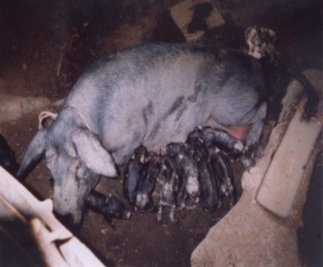
Mr. Durga showed keen interest in keeping pigs. He took training on care and management of improved pig breed (T&D). KVK under Front Line Demonstration gave 2piglets of T&D breed to him. He manages the pigs with keen interest and hard work. The piglets grew faster and healthier with the passage of time and attended body weight of about 70kg (female) 90kg (male) in one year. On 27.10.2006 the sow furrowed 6piglets fetched 6000 rupees to Mr. Majhi. The second furrowing on 12.06.2007 gave 10piglets fetched Rs. 10000.00 in cash after two months. Pigs were kept on grass, food residues/ kitchen waste and cooked broken rice under semi-intensive system health care & vaccination schedules were followed as per the standard practices seeing the profit by keeping a pair of pigs encouraged Mr. Durga, farmers of his neighboring villages to adopt piggery as an enterprise which could enhance the income level of farmers for their livelihood. The net profit earned was of Rs. 10000.00 (Rs. Ten thousand only) with investment of Rs. 2000 (on feed, medicines, Vaccines & miscellaneous) which excluded cost of piglets (Rs. 2000) by Mr. Majhi as he managed the pigs under backyard system (very low input on feed).

9. With the commencement of Krishi Vigyan Kendra, East Singhbhum in 2005-06 the experts of KVK engaged themselves to identify the potential areas where intervention could be made for a significant outcome. It was possible through exercising the different survey tools that in the Santhali dominant district one of the sectors with a tremendous potency was pig rearing.
With the aim of enhancing the productivity in pig farming T & D breed was chosen for the front line demonstration. First demonstration on the T & D breed was conducted in the villages Sidhadanga and Susnigaria of Ghatsila block. Farmer Durga Majhi was given a male and a female T & D piglets on the eve of first Kisan mela organised on 31st January 2006 at KVK. Both the farmers were trained for scientific ‘rearing of pig’. Regular visit by KVK experts to the farmer’s field and guidance strengthened their skills. Both the farmers managed their pigs with farm residues and kitchen wastes. By the end of the year 21 piglets were farrowed. With almost two farrowing per year received by the farmers there after. Till the end of 2008, Sri Durga Majhi of Sidhadanga had 28 piglets and Sri Diku Soren of Susnigaria got 60 piglets. They had respectively earned Rs. 30000.00 and Rs. 60000.00 each by selling the piglets. The grand and significant success in the view of KVK was a wide dissemination of the most suited, black colored, quick body weight bearing, highly prolific, well adoptive, disease resistant T & D breed among many villages of the district. A few could be named as Sukrigariya, Narga, Bhilaipahari, Kanyaluka, Roam & Cholagora, Jagannathpur, Naldoha etc are the villages under different blocks of the district.
With the perception that the breed was performing so well in the region KVK, East Singhbhum carried its voyage for its further dissemination through organising FLDs on pigs. In the year 2007, Prof J. Soreng, a retired person who adopted farming as a hobby was selected as a resource rich farmer for T & D’s demonstration in KVK’s adopted village Gorgora in Jamshedpur block. He participated in training programmes & workshops organised by KVK very frequently. Two males and four females of pigs were given in demonstration. Mr. Soreng’s dedicated, hard work and interest had emmersed his farm as a model pig farm for the new comers in pig rearing occupation. Now, he is maintaining about fifty pigs of T & D and could be able to provide piglets to the farmers of the East Singhbhum and Saraikela Kharsawan districts. His annual income through the sell of piglets was about Rs. 1.0 lakhs and finished pigs (fatteners) were Rs. 85000.00 (Rs. Eighty five thousand only).
By organising frequent training, workshops, exposure visits and field days at the successful farmers’ farm we were able to equip our farmers with the recent techniques of pig farming. Farmers of Bhagabandh, Baghuriya, Chakuliya, Gorgora, Jagannathpur, Ulda, Naldoha, Sunderdih are the one among many who have started pig farming as an enterprises. Their new venture has started rewarding good returns compared over their traditional pig rearing methods. Coming to the peroration, KVK, East Singhbhum with a dream sails in a boat of hope to continue its journey with the inspiring words that “Knowing is not enough; we must apply willing is not enough; we must do it.”
DETAILS OF FLD GIVEN IN THE LAST THREE YEARS
SL NO | NAME OF FARMERS | VILLAGE | BLOCK | YEAR OF DEMONS. | INCOME TILL 2008 (In Rs.) | NO OF PIG
1. | Durga Majhi | Sidhadanga | Ghatsila | 2006 | 30000.00 | 1M & 1F
2. | Diku Soren | Susnigaria | Ghatsila | 2006 | 60000.00 | 1 M & 2 F
3. | Matul Mardi | Lowkeshra | Musabani | 2007 | 4000.00 | 1 M & 2 F
4. | Subodh Mardi | Roam | Potka | 2007 | 5000.00 | 1M
5. | Jerom Soreng | Gorgora | Jamshedpur | 2007 | 70000.00 | 2M 4 F
6. | Dev kumar Soren | Baghuriya | Ghatsila | 2007 | 16000.00 | 2 F
7. | Sonaram Soren | Baghuriya | Ghatsila | 2007 | 10000.00 | 2 F
8. | Soken Soren | Sidhadanga | Ghatsila | 2008 | -- | 2 F
9. | Sankar Manjhi | Deoli | Ghatsila | 2008 | -- | 1 M & 1 F
10. | Biren Hansda | Banamghutu | Jamshedpur | 2008 | -- | 1 M & 1 F
Some of the farmers who started pig farming in different block of the districts (by taking trainings).
SL NO | NAME | VILLAGE | BLOCK | NO OF PIGS
1. | Mangal Murmu | Bhagabandh | Jamshedpur | 15
2. | N. Baskey | Sarjamda | Potka | 4
3. | D. Mardi | Sarjamda | Potka | 4
4. | B. Murmu | Baliguma | Jamshedpur | 2
5. | Sunil Hembrom | Birsanagar | Jamshedpur | 10
6. | Ratan |  | Patamda | 4
7. | Somai |  | Patamda | 4
8. | Sravan |  | Patamda | 4
9. | Ghuhiram Majhi |  | Dhalbhumgarh | 2
10. | Singrai Tudu | Kanyaluka | Dhalbhumgarh | 2
11. | Jasai Hansda | Bhadua | Musabani | 2
12. | Uma Sankar | Jugsalai | Jamshedpur | 30
13. | Sanatan Mardi | Raghunathpur | Chakulia | 10

10. It is a success story of Shri. Dev Kumar Soren, a rural youth of village Baghuria, Block Ghatsila in East Singhbhum. He is 22 years old youth having immense faith in Agriculture sector as a potent area for employment generation. He came in contact of Krishi Vigyan Kendra in 2006. After knowing the details of our mandate he availed training on integrated farming system. Mr. Dev being a resource poor youth was helped by KVK to have demonstrations on T&D pig (1male+ 1 female), vaccination camp for poultry, de-worming camp for livestock, mixed fish farming, INM and IPM modules. His faith in improved package of practices for farming and keenness in integrated farming system, KVK had planned for multi disciplinary intervention in his farm for the development of his farming system.
He had sufficient land holding (3.5 ha), men power (joint family with 7 members) and unexploited farm resources. During 2006-07 his annual production in paddy was about 50quintals from 2.5ha, 105 kg arhar from 0.5ha and mustard 55kg from 0.2ha. He cultivated vegetables in 0.1ha for house hold consumption. His livestock comprised of 2 bullocks for draft purpose, goat (5no.), cow (2no.) ha. for manure, goats to meet annual ceremonies and poultry for house hold meat consumption.
KVK team encouraged Dev and technically supported him by conducting on farm trial, front line demonstrations and provided need based training to him and his family members for different enterprises. The outcome of our endeavor produced excellent results (table A)
Sl no | Assets available | Area (ha) | Remarks
1. | Total land | 3.5
2. | Irrigated land | 0.5 | One pond
3. | Land under different crop | 2.5 | Paddy, maize, mustard, arhar & vegetables
4. | Livestock | 0.5 | T&D pigs, Bullocks, cow, poultry& goat
5. | Farm implements | 2 no | 1 Desi plough
6. | Pond(150x100)ft. | 0.2 | Mixed fish farming

Enterprises/ crop | Change in production |  | Net income during 2007-08 (Rs)
 | 2004-05 | 2007-08
Paddy | 50q | 100q | 30000 (from 50 q.)
Arhar | 1.05q. | 2.25q. | 2000 (from 1q.)
Mustard | 55 kg | 1.25q | 1600 (from 1 q.)
Maize | - | 1.5q. | 8000(from 1 q.)
Vegetables | - | 2q. | 6000 (1.5q.)
Livestock | 2pigs | 6 pigs(T&D) | 20000(16 no.)
poultry | 10desi birds | 80birds | 6000(60birds)
Total |  |  | 73600

Sri Dev Kumar Soren cultivated about 100quintals paddy, 1.5q maize, 2.25q pigeon pea and 1.25q. mustard. He marketed cucumber, potato, bottle gourd, brinjal, chilly and tomato worth Rs.6000.00 during 2007-08. He started commercial desi poultry rearing that fetched Rs.6000.00.A pair of T&D fetched Rs. 20000.00. He started mixed fish farming in his 14400sq. ft. pond. He has become a paravet for regular vaccination in poultry and first aid in ailing livestock in his locality.
Now, Sri Dev is a happy youth who dreams a bright future of his family in years to come by his agri-based farming system. Now the youths of his panchayat are motivated by the way Shri Dev has developed himself.
His success is a boon for the East Singhbhum KVK team.

11. Collaboration VS Drought

Damodih was a village in Potka block of the East Singhbhum district. The villagers were mostly dependent on agriculture and allied sectors. The inhabitants were all from Santhal tribal community. Since long they were suffering from the cruel punishment of nature i.e. uneven rain and drought like condition. Since last two years they faced acute crisis of paddy crop failure at sapling stage. They could not transplant paddy due to water scarcity. Livelihood of the villagers was in jeopardy. They were felt to lose confidence due to consecutive drought cursed by nature.
But it said that nature always gives ways and means of survival. The village Damodih was gifted by a perennial flowing stream named Gurra. It flowed in the southern part of the village. It was long felt need of the villagers for a lift irrigation system on the stream to irrigate about 500 acres cultivable land. In this direction Krishi Vigyan Kendra East Singhbhum conducted PRA survey in the village during 2008-09 to know the existing agricultural potential of the village and came to intervention that if a lift irrigation system was set on the stream, the cropping intensity could be increased upto 300 % easily over 1000acre. Realizing the fact Uranium Corporation of India Limited (UCIL), took initiative to set a lift irrigation system under their corporate social responsibility around its surrounding village of their mining areas.
Lift irrigation was set in the year 2010 during August-September when villagers were in acute need of crop at least in the rabi season. Both on and off campus training programme were organized to train farmers on rabi crop and vegetable production by KVK. Farmers’ scientist interaction was held to to breeze the technical gaps among the farmers. The irrigation canal was spread over 500 cultivable areas. On the recommendation of KVK ATMA East Singhbhum joined hands to further accelerate development speed by establishing Krishak Patsala where crop based package of practice were deliberated to the beneficiaries groups through organizing skill based training. During rabi-2010, the farmers cultivated wheat in 150 acre, vegetable in about 110 acre. the success achieved while growing Rabi crop boosted confidence of the farmers. UCIL has further assured to buy all the produce for their canteen paying genuine rate.
KVK East Singhbhum, UCIL and ATMA has worked in collaboration and synchrony with the dwellers of village Damodih to achieve growth in productivity and cropping intensity. They have also set an example in the district how inter institutional linkage and support can bring smile on the face of farmers.

12. INTEGRATED FARMING SYSTEM BOOST FARMERS INCOME
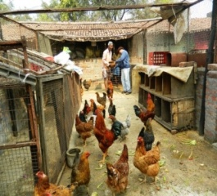
Jerome Soreng, a retired professor from Workers’ Collage, Jamshedpur, Jharkhand is only 71 years old young man who is setting example by doing what young people dream. He has an agricultural farm with a total Area of 2acres 15 decimal (215decimal) in which he has developed excellent integration of livestock- crop- vegetable-aquaculture with many creative and innovative ideas. The major livestock are pig followed by poultry, duck and fish production units in 45 decimals land. He grows crops including paddy, wheat, maize and potato. Cabbage, cauliflower, okra, banana, guards, tomato etc are seasonal vegetables produced by Prof. Jerome Soreng with an objective of enhancing productivity and profitability. The major enterprise is Piggery in which 40 decimal of land is utilized. There are concrete sheds with about 25 compartments. There are about 25 sows, 6 boars, 53 growers and 68 piglets in his farm. Various innovations in the pig farming made are:
- Digital weighing balance- It is nicely placed to weigh pigs of all age groups (weight ranging from 1 kg to 300kg). Marketable finishers whose body weight range between 70 to 250 kg or more can be conveniently weighed. Animals from all the sheds can be brought to the weighing chamber conveniently and without overlapping any chamber.
- Sprinklers for cooling during summer afternoons.
- Farm waste management- All farm produce are processed and packed. In the process farm waste like paddy husk, broken rice, vegetable leaves, roots, unmarketable produces, weeds, etc are obtained. These by-products are superiorly utilized for better feed conversion, therefore reducing in cost of production of livestock.
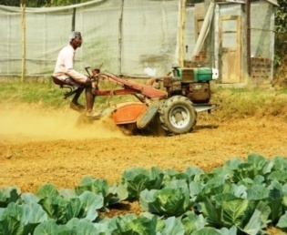
- Kitchen and hostel waste utilization- Major feed requirement is met by utilization of Kitchen and hostel waste obtained from urban areas of Steel City- Jamshedpur. It has not only reduced the burden of institutes to dispose eatable waste but at the same time encouraged many small and marginal farmers to begin pig rearing, the most suitable livestock to meet livelihood needs (both money and low cost animal protein).
- Torch bearer for hundreds of farmers to adopt pig farming as an enterprise: More than 500 farmers are brought and exposed in the farm to adopt the farming using low cost techniques of pig as well as integrated farming model.
- Efficient utilization of manpower- On an average full time engagement of Mr. Soreng and his team in his pig based integrated farming system.
- Mechanization- Feeding and garbage management both are done with self made self designed appliances and equipment making job drudgery free.
- Natural habitat for farrowing in sow: His experience in reproductive management, especially farrowing of sow in a warm, dark and dry pan proved safe and highly productive. Since temperature in summer is very high (may go as high as 45⁰C), he experienced high mortality therefore, innovation made was farrowing chamber in thick walled, thatched, false ceiling, preferably darker shed in which piglets are farrowing safely.
Other enterprises:
Backyard poultry farming: Poultry breeds- Vanaraja and Gram Priya (15 in no. each) are reared for meat and egg production respectively. The birds are managed using farm waste and kitchen waste. The average daily egg production is one dozen. It is sold and money generated is revolved for day today expense.

Early vegetable production- Jeromeji plans to execute time bound agriculture. He grows vegetables with an aim to bring its produce early to the market bringing higher returns. For it he grows seedling in low cost polyhouse.

13. Integrated Farming system model.
Name of farmer | Nakul Mahato
Village | Berahatu
Address | PO- Mahulia, Dist- East Singhbhum, Jharkhand Pin-832304
Contact details (Phone, mobile, email Id) | +91-9939307434
Landholding (in ha.) | 6ha
Irrigated (in ha.) | 1.5 ha
Un-irrigated (in ha.) | 4.5 ha
Membership details(in Self-Help Group, Producers  Cooperative/ Company, Cooperative Society etc.) | Members in SHG group
Brief about individual/ group (about 250 words) | Sri Nakul Mahto an inhabitant of village Berahatu, Block- Ghatshila, East Singhbhum started his farming under the guidance of Krishi Vigyan Kendra in a scientific way. Earlier Sri Mahato could not plan a better cropping pattern in his available farm resources. He used to keep his uplands barren and other resources unexploited. Sri Mahato in his young age decided the by farming he can earn more money than other work. He engaged in farming and allied activities in the age of 14 years. In the beginning he felt that what is very hard and complicated. The income from existing farming practices not enough to maintain the family.  Along with crop, oil seeds and pulses he started cultivation of vegetables and domesticating cattle, goat and poultry taking kin care in planning, management and market network under expert guidance of KVK Scientist. Mr. Nakul Mahto emerged himself as a successful and skilled farm owner with increase in productivity and profitability in his available farm resources. Sri Mahto has become an example for the local farmers
Write up on of success story (about 500 words) | In this district majority of the farmers are small and marginal. The nature of farming is subsistence. The package of practice are indigenous they use own technology based on the traditional practice.  As the day by day land holding are shrinkages and meet the demand of the families with the small holding becomes difficult. To meet the increasing demand with small price of land is challenging for Mr. Nakul Mahato. Initially he thought that of the yield of the crops or livestock to be increase. He will certainly be able to fulfil the demand of the families. He took part in the training programmes KVK and regular in consultation with the scientist of KVK for the strengthening of existing IFS. After training and consultation he feels that, these existing farming system models are subsistence in nature and the existing enterprises are not properly interlinked to make the system more efficient by adding some enterprises like dairy, poultry and goatry and off season vegetables.  IFS model of Mr. Nakul Mahato having enterprises like  1. Dairy (5cow+ 2 buffalo)  2. Paddy- 2acres  3. Vegetables: 3acres (Rabi & Kharif)  Potato-0.5 acre, cucumber-1 acre, tinda-1.0acre  Bottle gourd- 0.5acre  4. Desi poultry, duck, pigeon (60+5+60 nos)  5. Goat-5  Pond- For irrigation & fishery for home consumption  The major income comes from the dairy. The cow and buffalo are managed by the family members. He used the paddy straw and vegetable wastes that are not fit for marketing and use very little amount of concentrate fodder. He use the compost in his field received from cow, poultry and goat. He use improved package of practice like use of high yielding seeds of vegetable, methods integrated nutrient and pest management and proper marketing. In case paddy he use SRI method of paddy cultivation, in poultry, dairy, goatry and poultry semi intensive method and in vegetable cultivation he go for early and off seasons cultivation of cucumber, bottle gourd and tinda for better profit.
Factors responsible for success (e.g., individual efforts, leadership qualities, innovativeness, and support form Govt. Department, responsiveness to change etc.) | It is the individual effort and challenge of Mr. Nakul Mahato that with parental property using innovative ideas to increase the productivity, profitability and sustainability and make the farming cost effective. In the climatic charging scenario.
Impact of success story on other farmers in locality | Now Mr. Nakul use Motor cycle where he earlier use the by cycle for marketing milk & vegetable. He has package house and good reputation in the society. Many farmer in this locality are impressed by the success of the Mr. Nakul and many are adopting the IFS model.
Awards / rewards / appreciation received | Mr. Nakul received award from Birsa Agricultural University, Ranchi for his paddy winnowing & threshing machine. He made the tedious winnowing work by use table with power operated threshing. Earlier this work is done by manually which take more labours and time. He also got prize from KVK. District level & block level. In the area of integrated farming system model & on different enterprises like Goat & poultry.
Impact factor | Before Adoption | After Adoption
Crop / Agricultural Practice | Paddy- Broadcasting & without line sowing  Vegetables- Improves method of cultivation  Animal Husbandry- traditional practice | Paddy- SRI, Method  Vegetable- Improved method with INM & IPM approaches and off season  Animal Husbandry- Semi Intensive and better feed management with available farm produces.
Yield of crop / product | Paddy-50q, Vegetables-100q, Wheat-10q | Paddy-50q, Vegetables-500q, Wheat-30q, Milk-30ltr/ day, Poultry/duck- 200eggs/ year, goat-8
Sale Value | 375000.00 | 9,10,500.00
Input Cost | 75000.00 | 1,50,000.00
Labour Cost | 20000.00 | 50,000.00
Any Other Cost | 15000.00 | 25,000.00
Net Saving / Net Profit | 265000.00 | 6,85,500.00

14. Strengthening of existing farming system model
Majority of the farm of the district East Singhbhum district are marginal having less than 2.5 acre of land. Here agricultural activities are way of livelihood rather than commercial activity. The existing farming system model are different enterprise based like rice+ fallow, rice-vegetable, rice-vegetable-animal husbandry and rice-vegetable-animal husbandry-fishery are the major models. These model are not properly interlinked and supplementary to each other. Strengthening of each enterprises with improved technology and complimentary to each other existing model can be make more profitable and sustainable. These existing farming system and enterprise need intensification and diversification according to the available resources and changing situation. Enterprises can be intensifying by improved pacakage of practices like high yielding variety/breed, integrated nutrient management, integrated pest management, post harvest management and available natural resource management of individual farmers.
To increase productivity and profitability of different enterprises improved technology to be adopted like SRI method to increase productivity of rice, low cost poly house for early and of season vegetable cultivation and semi intensive management of backyard poultry, goatry and piggery farming. Some successful example of integrated farming system model

Pig based integrated farming system
Farm family status
- Total land-3.5 | 2.15 acres
- Cultivable land-3 | 2.15 acres
- Uncultivable land 0.5 | -
- Pond- | 0.20
Farm implements | Sprinkler,, Spreyer-1, Pumpset-1 power tiller, weighing machine, pickup van
No. of family members- | 8

Total annual income of J soreng
Crop/enterprise | Area (acres)/nos. | Production(qt.) | Cost of cultivation | Gross return | Net return
Pig | 0.40 | 120.00 | 400000 | 1200000 | 800000
poultry | 0.01 | 4.5 | 20000 | 70000 | 50000
duck | - | -Eggs and meat | 4000 | 14000 | 10000
fish | 0.20 | 1.3 | 3000 | 13000 | 10000
Vegetable and others crop | 1.30 | 35.0 | 5000 | 35000 | 30000
Total |  |  | 432000 | 1332000 | 900000

Green Dream Farm is a dream of Retd. Prof. Jarome Soreng, at Village Gorgora (Baliguma) in East Singhbhum. The dream has come true by the sincere endeavor of Mr. Soreng. His optimistic thinking, practical knowledge, faith in himself, strong will power and diehard working stamina has set an example as a successful pig breeder in his pig based farming system model.
The pig farming was started in April 2004 with 16 piglets brought from Ashirbad Farm, Namkum, Ranchifor Rs. 7390. By the end of 2004 the sows started farrowing. The net profit obtained from piglets encouraged him to go for a bigger farm. He felt the need of low cost feed material for raising pig. Some big canteens of TATA groups were contacted to provide their kitchen waste for economic pig production. In November 2006 vehicle TATA ACE was purchased for Rs. 251000/- to carry hostel and kitchen waste for the farm.
In the year 2007, Mr. J. Soreng came in touch with Krishi Vigyan Kendra, East Singhbhum. The subject matter specialist organised training programmes on scientific pig farming at KVK. Green Dream Farm was encouraged to take up breeding of pig with an aim to supply piglets to the farmers of the district under expert supervision of Dr. S.K.Singh, Dean, RVC, BAU, Ranchi. Pig growers of the district and adjoining districts took part in training programme organised off campus at G.D.Farm, Gorgora. KVK further demonstrated Performance of T& D pigs at the farm.
In the year 2008 the farm had become a centre for exposure and learning skill for the farmers of the district. Mr. Soreng took active role model among the pig growers of the region. He was frequently invited to share his valuable experiences to the new farmers interested in pig farming. By the end of the year more than 25 new farmers were attached with pig rearing. In the same year Birsa Agril. University awarded prize in the field of breeding and dissemination of T& D pig in the region. The strength of the farm had gone up to 100 pigs by the end of the year.
In 2009, the constant monthly gross turnover reached to Rs 70,000/- with a monthly net income around Rs. 54,000/-. In the same phase, Mr. Soreng, being interested in research carried study on economics of keeping Desi pig Vs T&D. And proved that Keeping T&D was feasible, profitable and easily marketable and demand driven.
In 2010 the marketing expanded beyond Jharkhand, i.e. W.B. and Orrisa. Green Dream Farm started integrating Fish cum Duck cum backyard Poultry cum pig along with crop and vegetable production with an aim of better utilization of resources and recycling of farm waste. This had proved better and covers greater ricks. He worked on farm mechanization and drudgery reduction through providing weighing machine, water supply and carry carts for feed. Now the credit of more than a 100 farmers doing pig rearing goes to Mr. Soreng’s endeavor which compels to dream about a successful pig farming in the region.
Now the time had come to rethink on the emerging problems like marketing, disease control, processing and other related issues on which in depth survey is being carried out to overcome the challenge. Workshops and seminars are being organised to focus on the issues getting expert advice of KVK.
Green Dream Farm is a dream of Retd. Prof. Jarome Soreng, at Village Gorgora (Baliguma) in East Singhbhum. The dream has come true by the sincere endeavor of Mr. Soreng. His optimistic thinking, practical knowledge, faith in himself, strong will power and diehard working stamina has set an example as a successful pig breeder in his pig based farming system `model.
The pig farming was started in April 2004 with 16 piglets brought from Ashirbad Farm, Namkum, Ranchifor Rs. 7390. By the end of 2004 the sows started farrowing. The net profit obtained from piglets encouraged him to go for a bigger farm. He felt the need of low cost feed material for raising pig. Some big canteens of TATA groups were contacted to provide their kitchen waste for economic pig production. In November 2006 vehicle TATA ACE was purchased for Rs. 251000/- to carry hostel and kitchen waste for the farm.
In the year 2007, Mr. J. Soreng came in touch with Krishi Vigyan Kendra, East Singhbhum. The subject matter specialist organised training programmes on scientific pig farming at KVK. Green Dream Farm was encouraged to take up breeding of pig with an aim to supply piglets to the farmers of the district under expert supervision of Dr. S.K.Singh, Dean, RVC, BAU, Ranchi. Pig growers of the district and adjoining districts took part in training programme organised off campus at G.D.Farm, Gorgora. KVK further demonstrated Performance of T& D pigs at the farm.
In the year 2008 the farm had become a centre for exposure and learning skill for the farmers of the district. Mr. Soreng took active role model among the pig growers of the region. He was frequently invited to share his valuable experiences to the new farmers interested in pig farming. By the end of the year more than 25 new farmers were attached with pig rearing. In the same year Birsa Agril. University awarded prize in the field of breeding and dissemination of T& D pig in the region. The strength of the farm had gone up to 100 pigs by the end of the year.
In 2009, the constant monthly gross turnover reached to Rs 70,000/- with a monthly net income around Rs. 54,000/-. In the same phase, Mr. Soreng, being interested in research carried study on economics of keeping Desi pig Vs T&D. And proved that Keeping T&D was feasible, profitable and easily marketable and demand driven.
In 2010 the marketing expanded beyond Jharkhand, i.e. W.B. and Orrisa. Green Dream Farm started integrating Fish cum Duck cum backyard Poultry cum pig along with crop and vegetable production with an aim of better utilization of resources and recycling of farm waste. This had proved better and covers greater ricks. He worked on farm mechanization and drudgery reduction through providing weighing machine, water supply and carry carts for feed. Now the credit of more than a 100 farmers doing pig rearing goes to Mr. Soreng’s endeavor which compels to dream about a successful pig farming in the region.
Now the time had come to rethink on the emerging problems like marketing, disease control, processing and other related issues on which in depth survey is being carried out to overcome the challenge. Workshops and seminars are being organised to focus on the issues getting expert advice of KVK.
Water harvesting based Integrated farming system
Farm family status of Matu mardi
- Total land-3.5 | 4.0 acres
- Cultivable land-3 | 3.0 acres
- Uncultivable land | 1.0 acres
- Pond- | 150x100ft.( 2 nos.)
Farm implements | Power tiller, Spreyer-1, Pumpset-1, paddy transplanter
No. of family members- | 5

Total annual income of Matu mardi
Crop/enterprise | Area (acres) | production | Cost of cultivation | Gross return | Net return
Rice | 4.0 | 40.00 | 18000 | 48000 | 30000
Wheat | 2.0 | 22.00 | 20000 | 35000 | 15000
Pig | 15 | 11.00 | 40000 | 115000 | 75000
Poultry | 35 | 0.25 | 4000 | 1200 | 2800
Duckery | 15 | Eggs-550 | 5000 | 1700 | 3300
Fishery | 150x100ft. ( 2 nos.) | 2.0 | 20000 | 5000 | 15000
pulses | 0.30 | 1.0 | 6000 | 1000 | 5000
Toata |  |  | 113000 | 206900 | 146100

Sri Matu Mardi son of Sri Yadunath Mardi is Inter Pass 38 years old rural youth of village Lowkeshra, Musabani has transformed himself as a progressive farmers after the inception of NICRA project in his village. He used to cultivate rice as mono-crop with traditional method & domesticate livestock like pig, poultry & sheep. He has a pond of 100 feet × 100 feet × 5 feet depth but was unproductive for many years due to lack of knowledge & awareness about integrated farming system. He neither stocked composite species of fishes nor integrated improved duck, pig breed & crops cultivation. On an average he get net profit of Rs. 29400.00 with the investment of Rs. 80000.00.
After getting guidance by the KVK scientists he constructed small hut during summer 2012, on the bank of pond. He clean the pond by removing all unwanted vegetation & cleaned the pond. He make outlet of pig house in to the pond & also add lime 4q/ha & cow dung 10q/ha in that pond on advise of the KVK scientists. In the month of July 2012 he added different species of fishes namely Rohu, Katla, Mrigal, Common carp, Grass Carp etc. as suggested by Scientists. Along with these he was supplied with 15 improved Khaki Campbell ducklings with 2(m) + 4 (F) pig (T × D) breed & in nearby adjoining areas he cultivated crops (eg. Mustard, Wheat, Gram) & vegetable (eg. Bitter gourd, Onion & Okra) & started integrating farming system in his land. Pig & duck excreta were the main source which benefited fishes, pond water was used to irrigate Rabi season crops whenever needed & vegetable wastes used as feed of duck & pig.
The overall productivity was found to increase tremendously & with investment of total amount of Rs. 141900.00 annually, he get net profit of Rs. 171500.00 in the first year (2013) that was ever noticed & gained by him earlier. The cost of cultivation will reduced in the coming year as he has not to invest money in pig, duck & infrastructure.
Now observing the benefits harnessed by Matu about 45% farmers in the localities having ponds have trying to adopt this model of farming system.
Vegetable based integrated farming system
Farm family status of Dev Kumar Sore

Total land-3.5 | 3.5 acres
Cultivable land-3 | 0.5 acres
Uncultivable land 0.5 | 0.5 acres
Pond- | 150x100ft.
Farm impliments | Deshi plogh-2, Spreyer-1, Pumpset-1
No. of family members- | 6

Total annual income of Dev Kumar Soren
Crop/enterprise | Area (acres) | production | Cost of cultivation | Gross return | Net return
Paddy | 3.0 | 80.00 | 20000 | 96000 | 76000
Arhar | 0.5 | 2.25. | 6000 | 11250 | 5250
Mustard | 0.5 | 1.25 | 2000 | 5000 | 3000
Maize | 0.3 | 2.5 | 1000 | 8000 | 7000
Vegetables |  | 2.00 | 18000 | 100000 | 82000
Livestock |  | 6 pigs(T&D) | 8000 | 28000 | 20000
poultry |  | 80birds | 1000 | 7000 | 6000
Total |  |  | 56000 | 227250 | 199250

It is a success story of Shri. Dev Kumar Soren, a rural youth of village Baghuria, Block Ghatsila in East Singhbhum. He is 22 years old youth having immense faith in Agriculture sector as a potent area for employment generation. He came in contact of Krishi Vigyan Kendra in 2006. After knowing the details of our mandate he availed training on integrated farming system. Mr. Dev being a resource poor youth was helped by KVK to have demonstrations on T&D pig (1male+ 1 female), vaccination camp for poultry, deworming camp for livestock, mixed fish farming, INM and IPM modules. His faith in improved package of practices for farming and keenness in integrated farming system, KVK had planned for multi disciplinary intervention in his farm for the development of his farming system.
He had sufficient land holding (3.5 ha), men power (joint family with 7 members) and unexploited farm resources. During 2006-07 his annual production in paddy was about 50quintals from 2.5ha, 105 kg arhar from 0.5ha and mustard 55kg from 0.2ha. He cultivated vegetables in 0.1ha for house hold consumption. His livestock comprised of 2 bullocks for draft purpose, goat (5no.), cow (2no.) ha. for manure, goats to meet annual ceremonies and poultry for house hold meat consumption.
KVK team encouraged Dev and technically supported him by conducting on farm trial, front line demonstrations and provided need based training to him and his family members for different enterprises. The outcome of our endeavor produced excellent results (table A)
Sri Dev Kumar Soren cultivated about 100quintals paddy, 1.5q maize, 2.25q pigeon pea and 1.25q. mustard. He marketed cucumber, potato, bottle gourd, brinjal, chilly and tomato worth Rs.6000.00 during 2007-08. He started commercial desi poultry rearing that fetched Rs.6000.00.A pair of T&D fetched Rs. 20000.00. He started mixed fish farming in his 14400sq. ft. pond. He has become a paravet for regular vaccination in poultry and first aid in ailing livestock in his locality.
Now, Sri Dev is a happy youth who dreams a bright future of his family in years to come by his agri-based farming system. Now the youths of his panchayat are motivated by the way Shri Dev has developed himself.

Dairy Based Integrated Farming System
Farm family status of Nakul mahato
Total land-3.5 | 3.5 acres
Cultivable land-3 | 0.5 acres
Uncultivable land 0.5 | 0.5 acres
Pond- | 150x100ft.
Farm impliments | Deshi plogh-2, Spreyer-1, Pumpset-1
No. of family members- | 6

Total annual income of Nakul Mahato
Crop/enterprise | Area (acres) | production | Cost of cultivation | Gross return | Net return
. Dairy | (5cow+ 2 buffalo) | Per day 30 litre | 60000 | 360000 | 300000
. Paddy- | 2acres | 50.00 | 18000 | 60000 | 42000
Vegetables: | 3.00 | 150.00 | 40000.00 | 120000 | 80000
Poultry, duck, pigeon | (60+5+60 nos) | - | 1000 | 8000 | 7000
Goat | 5 nos. | - | 3000 | 7000 | 4000
Total |  |  | 122000 | 555000 | 433000
In this district majority of the farmers are small and marginal. The nature of farming is subsistence. The package of practice are indigenous they use own technology based on the traditional practice.

Sri Nakul Mahto an inhabitant of village Berahatu, Block- Ghatshila, East Singhbhum started his farming under the guidance of Krishi Vigyan Kendra in a scientific way. Earlier Sri Mahato could not plan a better cropping pattern in his available farm resources. He used to keep his uplands barren and other resources unexploited. Sri Mahato in his young age decided the by farming he can earn more money than other work. He engaged in farming and allied activities in the age of 14 years. In the beginning he felt that what is very hard and complicated. The income from existing farming practices not enough to maintain the family.

As the day by day land holding are shrinkages and meet the demand of the families with the small holding becomes difficult. To meet the increasing demand with small price of land is challenging for Mr. Nakul Mahato. Initially he thought that of the yield of the crops or livestock to be increase. He will certainly be able to fulfil the demand of the families. He took part in the training programmes KVK and regular in consultation with the scientist of KVK for the strengthening of existing IFS. After training and consultation he feels that, these existing farming system models are subsistence in nature and the existing enterprises are not properly interlinked to make the system more efficient by adding some enterprises like dairy, poultry and goatry and off season vegetables.

IFS model of Mr. Nakul Mahato having enterprises like
1. Dairy (5cow+ 2 buffalo)
2. Paddy- 2acres
3. Vegetables: 3acres (Rabi & Kharif)
Potato-0.5 acre, cucumber-1 acre, tinda-1.0acre
Bottle gourd- 0.5acre
4. Desi poultry, duck, pigeon (60+5+60 nos)
5. Goat-5
Pond- For irrigation & fishery for home consumption
The major income comes from the dairy. The cow and buffalo are managed by the family members. He used the paddy straw and vegetable wastes that are not fit for marketing and use very little amount of concentrate fodder. He use the compost in his field received from cow, poultry and goat. He use improved package of practice like use of high yielding seeds of vegetable, methods integrated nutrient and pest management and proper marketing. In case paddy he use SRI method of paddy cultivation, in poultry, dairy, goatry and poultry semi intensive method and in vegetable cultivation he go for early and off seasons cultivation of cucumber, bottle gourd and tinda for better profit.

